**Faculty Profile**

a. Name: Sushree Sangeeta Sarap

b. Designation: Guest Faculty in Department of Anthropology, Government college Sundargarh

c. Qualification: M.Phil., Pursuing PhD ( Thesis Submitted)

d. Specialization: Social Anthropology

e. Area of Studies: Tribal Studies

f. Experience:

* Teaching Experience: Two years in the Regular mode of Education as Guest Faculty and four years in Distance mode of education at Odisha State Open University as Assistance Professor (Contractual) in Tribal Studies..
* Research Experience: One Year Research Experience During Nabakalebara 2015, at Puri.

g. Email: sangeetasarap02@gmail.com

h. Mobile No.: 7873476924

i. Profile

**FACULTY BIO**

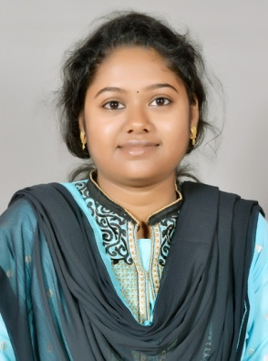

**Sushree Sangeeta Sarap** is currently working as faculty in the department of Anthropology at Government College, Sundargarh. She is Pursuing **Doctor of Philosophy (Ph.D.)** in Anthropology and completed **Master of Philosophy (M.Phil)** in **Anthropology at Sambalpur University**.

She experienced two year in **teaching (**regular mode of Education)in **India** as well as in **Germany** and one year as **Research Assistant** in socio-cultural Anthropology in the field of **Research.** She has also three years of experience asan **Academic Consultant in Tribal Studies at Odisha State Open University**, Odisha, India and having sound knowledge on ODL System with several Certifications such as MOOCs, etc. She also designed and developed a **one year Diploma Course in Tribal Studies** and managing on her own which was offered by OSOU.

She was a part of a scholarship program of **“a New Passage to India”** sponsored by **DAAD** an **Exchange student study Programs** to the Department of Social and Cultural Anthropology University of **Tubingen, Germany** from 01.05.2014 to 25.07.2014.